User Defined Exception
User defined exception is manually defined by the users as suggested by the name. For example, while developing a simple HTML form we want to throw an exception when the password length is less than 8 than such exceptions are used.
Syntax
class UserDefinedException extends Exception{
}
In the following program, we have created a user-defined exception by extending Exception class. We provide the exception information through try and catch block.
Through catch block, we provide the bracket e and hold the information that this is an exception of Exception, FileNotFoundException, UserDefinedException which is customized created.
Then keyword “throw” is used to create a new Exception (Exception, FileNotFoundException, UserDefinedException) and throw it to the catch block. “throw” keyword always written inside the method.
class UserDefinedException extends Exception{
}
public class App {
public static void main(String[] args) {
try {
someMethod();
} catch (FileNotFoundException e) {
System.out.println("catch block of main method(FileNotFoundException)");
} catch (UserDefinedException e) {
e.printStackTrace();
}catch (Exception e) {
System.out.println("catch block of main method (Exception)");
}

}
public static void someMethod() throws Exception,FileNotFoundException, UserDefinedException {
int x = 3;
switch (x) {
case 1:
throw new FileNotFoundException();
case 2:
throw new Exception();
default:
throw new UserDefinedException();
}
}
}
In Java, there are two types of exceptions:
- Checked exceptions
- Unchecked exceptions.
Java makes this division of exceptions depending on the level of importance of the exception. The checked exceptions are handled by the java compiler itself and the unchecked exception are handled by the user (not mandatory) in case of occurrence of such exceptions.
If any code within a method throws a checked exception, then the method must handle the exception or must specify the exception using the keyword throws.
For example, consider the following Java program we make use of FileReader class object and initialize it. The program is not compiled, because the main function uses FileReader() and FileReader() throws a checked exception FileNotFoundException.
To fix the above program, we need to specify the list of exceptions using throws, or we need to use a try-catch block. We have used try and catch block in the following program.
import java.io.FileNotFoundException;
public class App {

public static void main(String[] args) {

try {
FileReader in = new FileReader("file.txt");
} catch (FileNotFoundException e) {
// TODO Auto-generated catch block
e.printStackTrace();
}

}
}
Unchecked exceptions are not checked at compile time. All exceptions are disabled, so the compiler does not force them to handle or specify the exception. This is handled by the user (not mandatory) in case of the occurrence of such exceptions.

Consider the following Java program. It compiles well but throws ArithmeticException when it runs. The compiler allows you to compile because ArithmeticException is an unchecked or runtime exception.
public static void main(String[] args) {
int x = 10,y;
y = x/0;
System.out.println(y);
}

Multi-Catch: (Java catch: Multiple Exceptions)
Separated by |
try {}
catch (Exception1|Exception2|Exception3){}
Multiple Exceptions handled by a single catch block
Benefits:
Readable, Not Verbose, Not redundant
Readability means that the code is easy to follow, logically.
- Standards of indentation and formatting are followed so that the code and its structure are clearly visible.
- Variables are named meaningfully so that they communicate intent.
- Comments, which are present only where needed, are concise and adhere to standard formats.
- Guard clauses are used instead of nested if statements.
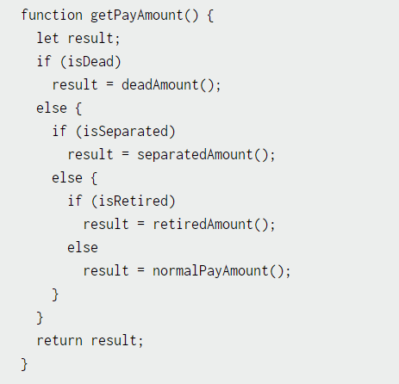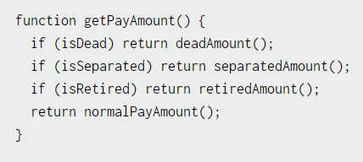
- Facilities of the language are used skillfully, leveraging iteration and recursion rather than copy and paste coding.
- Functions are short and to the point, and do one thing.
- Indirection is minimized as much as possible, while still maintaining flexibility.
Not Verbose means write the code without using more descriptive code. Use fewer words and symbols.
Not redundant means no need to write some common code for all exception (catch) block.
Question 1: What would be the output of this program? (Pay particular attention to catch block)
public static void main(String[] args) {
try {
int result = 100 / 0;
System.out.println("result : " + result);
System.out.println(myArray[10]);
} catch (ArithmeticException ae | ArrayIndexOutOfBoundsException ie) {
System.out.println("ArithmeticException : " + ae.getMessage());
System.out.println("ArrayIndexOutOfBoundsException: " + ie.getMessage());
}
}
- Compilation Error
- Run-Time Error
- No Error
Question 2: Which delimiter is used to separate multiple exceptions?
- # (Hash)
- , (Comma)
- | (Single Pipe)
- || (Double Pipe)
For ArithmeticException, call method m1()"
For NullPointerException, call method m2()
For ArrayIndexOutOfBoundsException, call method m3()
Questions for this assignment
Assignment:
package javaVersions;

public class MultiCatchDemo {
public static void main(String[] args) {

int myArray[] = new int[5];

String nullString = null;

try {
int result = 100 / 0;

System.out.println(myArray[10]);

nullString.equals("JFF");

} catch (ArithmeticException | ArrayIndexOutOfBoundsException | NullPointerException e) {

System.out.println("Exception in the main method");

// For ArithmeticException, call method m1()"

// For NullPointerException, call method m2()

// For ArrayIndexOutOfBoundsException, call method m3()

}

}

}

Answer
public class TestJavaVersion {
static void m1() {
System.out.println("m1");
}

static void m2() {
System.out.println("m2");
}

static void m3() {
System.out.println("m3");
}

public static void main(String[] args) {
int myArray[] = new int[5];
String nullString = null;
try {
int result = 100 / 0;
System.out.println(myArray[10]);
nullString.equals("JFF");

} catch (ArithmeticException | ArrayIndexOutOfBoundsException | NullPointerException e) {

System.out.println("Exception in the main method");
if (e instanceof ArithmeticException) {
m1();
}
if (e instanceof NullPointerException) {
m2();
}
if (e instanceof ArrayIndexOutOfBoundsException) {
m3();
}
// For ArithmeticException, call method m1()"

// For NullPointerException, call method m2()

// For ArrayIndexOutOfBoundsException, call method m3()

}

}

}

